

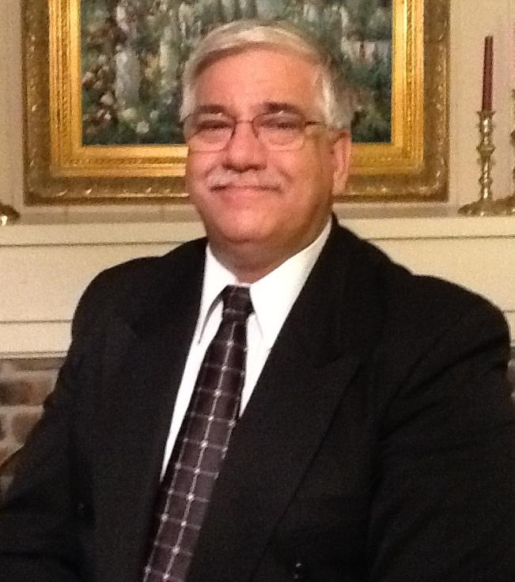

**Matthew J Beebe - CEO/President**

Matthew Beebe has over 25 years of experience in IT operations and has proven expertise and skills in managing large enterprise systems including software design, development, implementation and operations.

He has a BA in Public Relations and Advertising and has some experience in television operations, photography and videography.

Matthew has been flying large scale radio controlled fixed wing and multi-rotor aircrafts for over 8 years. He is a licensed ham radio operator and currently working on his private pilot license.

As a result of Matthew’s love of flying, his understanding of photography and videography and his IT design and development expertise, he changed careers and started GA UAV Services, LLC.

**David Price - Consulting Operations Director**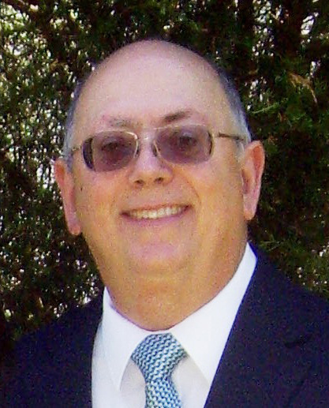

Dave Price recently joined GA UAV Services, LLC as our Consulting Operations Director. He is the senior member of the GTRI/ATASL Unmanned Aerial Systems flight test team. The team is comprised of 5 to 8 full-time researchers, with specialties in power plant & propulsion, airframe, sensors & payload integration, aerial imaging, software design, and systems engineering. The team includes members from 5 GTRI Laboratories to support specific missions or programs with the technology needed.

In addition to being a UAS pilot and radio/comms specialist, since 2006, Mr. Price’s responsibilities have become primarily interface with FAA and military ranges. Here, he composes applications to obtain flight approval in restricted military airspace as well as National Airspace System. He currently holds 25 active FAA Certificate of Authorization waivers (COAs), more than any other university.

Dave Price has been trained on multi-rotor UAS at U.S. Army base Ft. Benning, Georgia, after which he flew a UAS for police S.W.A.T. officers in a simulated active shooter exercise. He has been an active builder and pilot of amateur UAS since 1986.